**WEB DEVLOPMENT ASSIGNMENT - 6**

Name : Ashutosh Farswan

Roll: 20

Section: DS

Q1: Printing an array into Zigzag fashion. Suppose you were given an array of integers, and you are told to sort the integers in a zigzag pattern. In general, in a zigzag pattern, the first integer is less than the second integer, which is greater than the third integer, which is less than the fourth integer, and so on. Hence, the converted array should be in the form of e1 < e2 > e3 < e4 > e5 < e6.

### **Test cases:**

Input 1:

7

4 3 7 8 6 2 1

Output 1:

3 7 4 8 2 6 1

Input 2:

4

1 4 3 2

Output 2:

1 4 2 3

<html>

<body>

<script>

function zigzack(arr,n){

var flag = true;

for(var i = 0; i < arr.length-1; i++){

if (flag){

if (arr[i] > arr[i + 1]){

var temp = arr[i];

arr[i] = arr[i + 1];

arr[i + 1] = temp;

}

}

else{

if (arr[i] < arr[i + 1]){

var temp = arr[i];

arr[i] = arr[i + 1];

arr[i + 1] = temp;

}

}

flag = !flag;

}

return arr;

}

const a1 = [4,3,7,8,6,2,1];

const a2 = [1,4,3,2];

console.log(zigzack(a1));

console.log(zigzack(a2));

</script>

</body>

</html>

**OUTPUT:**

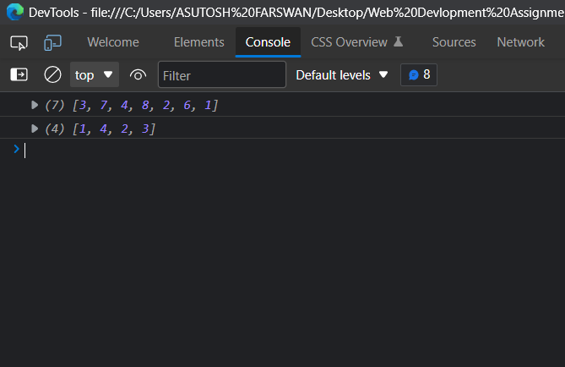

Q2: The problem to rearrange positive and negative numbers in an [array](https://www.faceprep.in/procoder/knowledgebase/introduction-to-arrays) .

Method: This approach moves all negative numbers to the beginning and positive numbers to the end but changes the order of appearance of the elements of the array.

Steps:

1. Declare an array and input the array elements.
2. Start traversing the array and if the current element is negative, swap the current element with the first positive element and continue traversing until all the elements have been encountered.
3. Print the rearranged array.

Test case:

* Input: 1 -1 2 -2 3 -3
* Output: -1 -2 -3 1 3 2

<html>

<body>

<script>

function rearrange(arr){

var pos = 0;

for(var i=0;i<arr.length;i++){

if(arr[i]<0 && pos!=i){

var temp = arr[pos];

arr[pos] = arr[i];

arr[i] = temp;

pos++;

}

}

return arr;

}

const arr = [1,-1,2,-2,3,-3];

console.log(rearrange(arr));

</script>

</body>

</html>

**OUTPUT:**

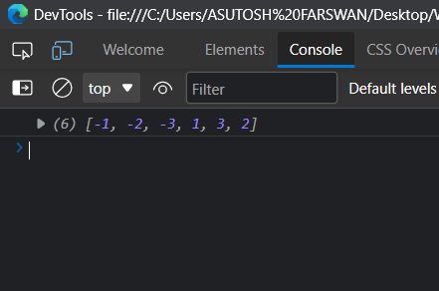

Q3: Program to find all the patterns of 0(1+)0 in the given string. Given a string containing 0's and 1's, find the total number of 0(1+)0 patterns in the string and output it.

0(1+)0 - There should be at least one '1' between the two 0's.

For example, consider the following string.

**Input:**01101111010

**Output:**3

**Explanation:**

**0110**1111010 - count = 1

011**011110**10 - count = 2

01101111**010**- count = 3

Step to find all the patterns of 0(1+)0 in the given string

* Input the given string.
* Scan the string, character by character.
* If the given pattern is encountered, increment count.
* Print count.

Program to find all the patterns of 0(1+)0

<html>

<body>

<script>

function count(){

var str = document.getElementById("str").value.toString();

var last = str.charAt(0);

var i = 1, c = 0;

while (i < str.length){

if (str.charAt(i) == '1' && last == '0')

{

while (str.charAt(i) == '1')

i++;

if (str.charAt(i) == '0')

c++;

}

last = str.charAt(i);

i++;

}

document.getElementById("c").innerHTML = "count:" + c;

}

</script>

<label> String : </label> <input type=text id="str" name="str">

<br>

<br>

<button onclick="count()"> count </button>

<h4 id = "c"></h4>

</body>

</html>

**OUTPUT:**

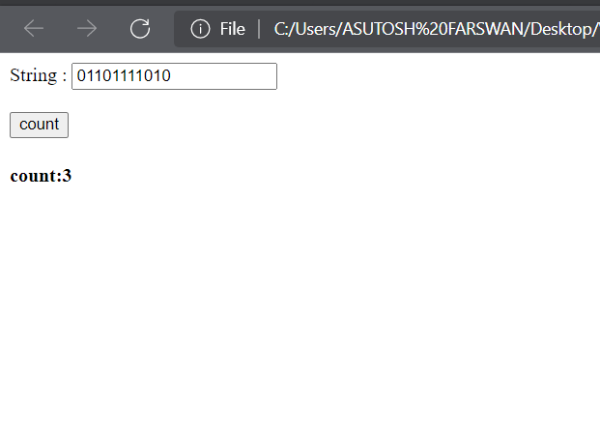

Q4. Write a Java script program to o find all pairs of elements in an Array whose sum   
 is equal to a given number.

## Array numbers= [4, 6, 5, -10, 8, 5, 20], target=10

## **Output :**

Pairs of elements whose sum is 10 are :  
4 + 6 = 10  
5 + 5 = 10  
-10 + 20 = 10

<html>

<body>

<script>

function findpair(a){

var text = " ";

for(var i=0;i<a.length-1;i++){

for(var j= i+1;j<a.length;j++){

if(a[i]+a[j] == 10){

text += `${a[i]} + ${a[j]} = 10 <br>`;

}

}

}

document.write(text);

}

var a = [4, 6, 5, -10, 8, 5, 20];

findpair(a);

</script>

</body>

</html>

**OUTPUT:**

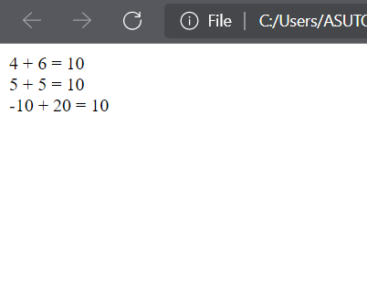

Q5: Given two sorted arrays A and B of size p and q to merge elements of A with B by maintaining the sorted order i.e. fill A with first p smallest elements and fill B with remaining elements.

Example:  
Input :  
int[] A = { 1, 5, 6, 7, 8, 10 }  
int[] B = { 2, 4, 9 }  
Output:  
Sorted Arrays:  
A: [1, 2, 4, 5, 6, 7]  
B: [8, 9, 10]

<html>

<body>

<script>

let arr1=[1, 5, 6, 7, 8, 10 ];

let arr2=[2, 4, 9 ];

function merge(m,n)

{

for (let i=n-1; i>=0; i--)

{

let j, last = arr1[m-1];

for (j=m-2; j >= 0 && arr1[j] > arr2[i]; j--)

arr1[j+1] = arr1[j];

if (j != m-2 || last > arr2[i])

{

arr1[j+1] = arr2[i];

arr2[i] = last;

}

}

}

merge(arr1.length,arr2.length);

document.write("After Merging <br>First Array: ");

for(let i=0;i<arr1.length;i++)

{

document.write(arr1[i]+" ");

}

document.write("<br>Second Array: ");

for(let i=0;i<arr2.length;i++)

{

document.write(arr2[i]+" ");

}

</script>

</body>

</html>

**OUTPUT:**

